Advanced Social Work Practice Behaviors

to Address Behavioral Health Disparities

Funded by:
Behavioral Health Disparities Practice Behaviors

U.S. Department of Health and Human Services Office of Minority Health
Prepared by:

National Association of Deans and Directors
of Schools of Social Work

Contents
Behavioral Health Disparities Practice Behaviors
Overview 1
Authors | Executive Committee 2
Introduction 3
Advanced Competencies and Practice Behaviors
2.1.1 7
Identify as a professional social worker and conduct oneself with cultural humility.
2.1.2................................................................................................................................................................................... 8
Apply social work ethical principles to guide professional practice approaches to address behavioral health disparities and health equities.
2.1.3................................................................................................................................................................................... 9
Apply critical thinking to inform and communicate professional judgments.
2.1.4.................................................................................................................................................................................10
Engage diversity and difference in practice.
2.1.5.................................................................................................................................................................................11
Advance human rights and social and economic justice.
2.1.6.................................................................................................................................................................................12
Engage in research-informed practice and practice-informed research.
2.1.7.................................................................................................................................................................................13
Apply knowledge of human behavior and the social environment.
2.1.8.................................................................................................................................................................................14
Engage in policy practice to address the social determinants of health, advance social, economic, psychological and environmental well-being and deliver effective culturally- grounded social work services to prevent, reduce and eventually eliminate behavioral health disparities.
2.1.9.................................................................................................................................................................................15
Respond to contexts that shape practice.
2.1.10 .............................................................................................................................................................................16
Engage, assess, intervene and evaluate with individuals, families, groups, organizations and communities.
a.Engagement 17
- Assessment 17
- Intervention 17
- Evaluation 18
References 19
Panel Participants 25
About NADD 27

Overview
This publication is based on research conducted by the National Association of Deans and Directors of Schools of Social Work (NADD) and proceedings from the 2012 Behavioral Health Disparities Curriculum Infusion Project National Panel Meeting on Advanced Practice Behaviors meeting under the guidance of the Behavioral Health Disparities Curriculum Infusion Initiative Executive Committee. The Behavioral Health Disparities Curriculum Infusion Project is funded by a grant from the Office of Minority Health, the U.S. Department of Health and Human Services.

The views, opinions and content expressed in this publication are those of the authors and conference participants and do not necessarily reflect the views, opinions or policies of the Office of Minority Health, the U.S. Department of Health and Human Services, or the National Association of Deans and Directors of Schools of Social Work.

This document is in the public domain and may be used and reprinted without permission except for noted copyrighted materials for which further reproduction is prohibited without the specific permission of copyright holders. Appropriate citation is requested by the authors when the document is cited.

Authors: James Herbert Williams, PhD., MSW, MPA Teresa Chapa, PhD, MPA
Eric A. Des Marais, MSW

Behavioral Health Disparities Curriculum Infusion Initiative Executive Committee

Federal Staff: Teresa Chapa, PhD, MPA
Senior Policy Advisor, Mental Health US DHHS Office of Minority Health Rockville, MD

NADD Representatives Laura Lein, PhD
Dean & Katherine Reebel Collegiate Professor of Social Work Professor of Social Work and Professor of Anthropology School of Social Work
University of Michigan Ann Arbor, MI

Larry Ortiz, PhD, MSW
Professor of Social Work & Social Ecology Department of Social Work and Social Ecology Loma Linda University
Loma Linda, CA

Edwina S. Uehara, PhD, MSW
Professor & Ballmer Endowed Dean of Social Work School of Social Work
University of Washington Seattle, WA

James Herbert Williams, PhD., MSW, MPA Dean & Milton Morris Endowed Chair Graduate School of Social Work
University of Denver Denver, CO

Advanced Social Work Practice Behaviors to Address Behavioral Health Disparities

Introduction
A new commitment to eliminating health and health care disparities is underway. For several decades, governmental and non-governmental organizations, including the World Health Organization, Institute of Medicine, and the U.S. Department of Health and Human Services have worked diligently to identify and define health and behavioral health disparities while attempting to achieve health equity for all. Landmark reports, legislation and standards helped drive new policies, programs and practices aimed at establishing viable public health and service models that are culturally and linguistically appropriate (Bravermen, 2006; US HHS, National CLAS Standards, 2013; Dahlgren & Whitehead, 2007; Grando-Villar et al., 2010; Huang & Chau, 2012; Smedley, Stith, & Nelson, 2002; U.S. Congress, 2010; US HHS, Secretary’s Report, 2011; Whitehead, 1992; WHO: Commission on Social Determinants of Health, 2008). As the United States increasingly diversifies, addressing health inequities is becoming more urgent.
It is estimated that by 2050, the majority of the U.S. population will be comprised of racial and ethnic minorities (Mather, Pollard, & Jacobsen, 2011; U.S. Census, 2012). Disadvantaged population and social groups, particularly racial and ethnic minorities and those with limited English proficiency, systematically experience worse health and behavioral health risks and outcomes (Braverman, 2006; US HHS SAMHSA Mental Health: Culture Race and Ethnicity, 2001). Given the population growth and changing demographics across the world, health disparities must be addressed and solved. Considering this level of discourse across health, behavioral health and social welfare disciplines to address health disparities, progress has been negligible in reducing gaps in health access, quality and outcomes (Williams, Costa, Odunlami, & Mohammed, 2008).

population will be comprised of racial and ethnic minorities.
”
Despite decades of efforts to improve and protect the health of racial and ethnic minority populations, disparities persist in health, safety and wellbeing, infrastructure and workforce, scientific knowledge and innovation (U.S. Department of Health and Human Services Plan to Reduce Health Disparities, 2010). Evidence shows that racial and ethnic minorities experience worse outcomes for health, behavioral health, substance abuse and disability when compared with Whites, even when receiving services (Sue & Chu, 2003; U.S. Department of Health and Human Services, 2001; Williams, Costa, Odunlami, & Mohammed, 2008). A lack of diversity and representation of racial and ethnic minorities in the health and behavioral health workforce continues to contribute to barriers to improving access to quality care. Targeted efforts to build a diverse and culturally competent workforce must be part of our nation’s educational and workforce plan (Chapa & Acosta, 2010; U.S. Department of Labor, 2011).

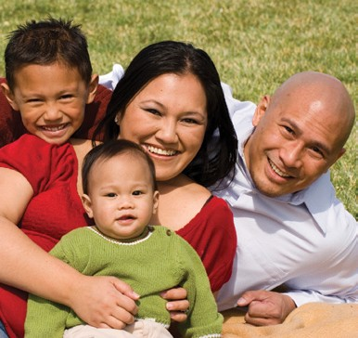Similar to disparities in health care, behavioral health disparities exist in access, delivery and quality of care. As a concept, behavioral health refers to the relationship between physical and psychological well-being
“
It is estimated that by 2050, the
majority of the U.S.

of the body and mind (Matarazzo, 1980). The study of behavioral health encompasses a range of health, mental health and substance abuse disorders, recognizing that the biological and psychological components occur within a larger societal and cultural context while also stressing the ability of individuals to proactively affect change in their own lives. Within this context, health is impacted by personal choice, health and behavioral delivery systems, social determinants of health, social inequality, beliefs, geography, religion, sexual orientation, educational attainment, family structure, oppression, culture and historical precursors (Brave Heart, 2003; Kumanyika & Morssink, 2006; Nagata, 1998; Smedley, 2006; Steinberg, 1989; Whitebeck, Adams, Hoyt & Chen, 2004; US DHHS, 2001; Yehuda, 1999).
Behavioral health care is an umbrella term and refers to a continuum of services for individuals at risk of, or suffering from, mental, behavioral or addictive disorders, as well as health behaviors. Behavioral health services include mental health, psychiatric, marriage and family counseling, addictions prevention and treatment, and public health. Finally, behavioral health services are typically provided by social workers, counselors, psychologists, psychiatrists and other physicians, as well as community health workers, health representatives, promotores de salud, health navigators and case managers (Peek, C. J. & the National Integration Academy Council, 2013).

mortality rates from health complications associated with substance use...
While overall prevalence rates for mental health and substance abuse diagnoses are generally similar across racial and ethnic groups, minority populations tend to suffer greater impacts and worse outcomes (McGuire & Miranda, 2008; US DHHS, 2001). Racial and ethnic groups tend to experience higher mortality rates from health complications associated with substance use, with Alaska Natives and American Indians experiencing mortality rates five times that of the general population for heart disease and stroke (Casper et al., 2005; Lo & Cheng, 2011, Indian Health Service, 2011). Racial and ethnic minorities also experience higher levels on subclinical measures of mental stress. In a study examining depression among a community population, Brondolo and colleagues found that both Blacks and Latinos have higher rates of self-report for feeling sad and hopeless every day for two or more weeks (Brondolo et al., 2009). Racial and ethnic youth fare worse than non-Latino Caucasians for emotional distress, physical health, teen births and school achievement (Cauce, Cruz, Corona, & Conger, 2010; Center for Disease Control and Prevention, 2010). Finally, minority communities often have fewer

sources of health care than non-Hispanic white communities or none at all (Institute of Medicine, 2003).
“
Racial and ethnic groups tend to
experience higher
”
Health disparities are impacted by a constellation of social determinants including poverty, employment, neighborhood violence, community disorganization, underperforming schools, trauma, racism, discrimination, social isolation, acculturation stress, lack of health insurance and poor access to health care (Braveman, Egerter, & Mockenhaupt, 2011; Brondolo, Gallo, & Myers, 2009; US DHHS, 2001; Healthy Communities Matter, 2010). These social determinants are cumulative and increase levels of stress that directly impact health and behavioral health of racial and ethnic minorities (Healthy Communities Matter, 2010; Kaholokula, Macapoy, & Dang, 2009). According to Williams & Mohammed (2009), racism and perceived discrimination have negative impacts on health, mental health and substance use. Furthermore, racial and ethnic minorities

are often exposed to higher levels of stress, impoverished environments, violence, trauma and social disruption; all linked to higher rates of mental disorders and substance use. Children exposed to these social determinants tend to have poor school performance, increased behavioral problems and a higher likelihood of depression (Cauce, Cruz, Corona, & Conger, 2010; Healthy Communities Matter, 2010; Stein et al., 2003). Historically oppressed groups also face the added difficulty of the effect of generations of cultural disruption and destruction known as historical trauma (Brave Heart, 2003). Evidence of the power of historical trauma has been identified in American/Alaska Natives, survivors of the European Holocaust, and Japanese American Internment camp survivors (Nagata, 1998; Steinberg, 1989; Yehuda, 1999). Children of trauma survivors also report higher levels of cumulative stress and PTSD, suggesting a multi-generational
impact of such historical events (Nagata, 1998; Steinberg, 1989; Yehuda, 1999).

sources of health and behavioral health care...
”
Several studies examining the role of racial and ethnic identity in health and behavioral health disparities have shown evidence that a strong sense of ethnic identity serves as a protective factor against discrimination, leading to better academic outcomes and general physical and mental health, while other studies have found that a strong sense of ethnic identity does not buffer against depression (Brondolo, Brady, Pencille, Beatty, & Contrada, 2009; Whitbeck, Hoyt, Stubben, & LaFromboise, 2001). LaFromboise and colleagues, (2006) found that a strong ethnic identity among American Indian youth was associated with pro-social outcomes; with similar effects found for adults (Children’s Defense Fund, 2011; LaFromboise, Hoyt, Oliver, & Whitbeck, 2006; Whitbeck, McMorris, Hoyt, Stubben, & LaFromboise, 2002).
Studies examining the role of religious and spiritual practices among racial and ethnic minority communities denote healthier behaviors and overall wellbeing, with lower rates of mental illness and substance use, and increased engagement and utilization of treatment services (Ortiz, Arizmendi, & Cornelius, 2004). American Indians, Native Hawaiians, Hispanic/Latinos, and Alaska Natives often use traditional approaches before seeking-out the western health care paradigm (e.g., herbal remedies, folk healers and prayer) (US DHHS, 2001; Ortiz, Arizmendi, & Cornelius, 2004). Concerns have been raised that racial and ethnic minorities utilize religious and spiritual leaders

and organizations in lieu of services provided by mainstream behavioral health care professionals (Davis, 2011; Gallo, et al, 2009; Koenig, 2009). However, a failure to recognize cultural beliefs and traditions can result in high levels of frustration for patients, misdiagnosis, ineffective treatment and, ultimately, lack of follow through for behavioral care plans that fail to consider the whole person (Ida et al., 2012). Culturally competent care is essential to improve the quality of overall health care and reduce health disparities. The intersection of traditional and mainstream treatment must be met with an experienced and culturally sensitive
“
Racial and ethnic minorities tend
to have fewer
approach _further validating the need for cultural and linguistic competency and training (US HHS, National
CLAS Standards, 2013).
Racial and ethnic minority communities tend to have fewer sources of health and behavioral health care, and a number of factors have been cited as barriers to quality care. Although the lack of health insurance is the single largest predictor of non-utilization of health care services (Agency for Healthcare Research and Quality,

2012), mistrust of health care institutions, lack of knowledge of available resources, language barriers, and stigma about mental health and illness also contribute to disparities, further reinforcing the need to build a workforce that will deliver culturally and linguistically competent care to a diverse population (Escarce & McGuire, 2004; Hasnain-Wynia, Baker, Nerenz, Feinglass, Beal, Landrum, Behal, and Weissman, 2007; Jha, Fisher, Li, Orav, & Epstein, 2005; Klonoff, 2009; Schneider, Zaslavsky, & Epstein, 2002; Trivedi, Zaslavsky, Schneider, & Ayanian, 2006; US HHS, National CLAS Standards, 2013).
Lack of diversity among the health and behavioral health care workforce is also considered a significant contributor to disparities in care for minority and LEP populations because it limits availability, access and engagement to culturally and linguistically competent care (Chapa & Acosta, 2010; Greer, 2005; McGuire & Miranda, 2008). African Americans, American Indian/Alaska Natives and Latinos are severely underrepresented as physicians, registered nurses, clinical social workers and psychologists. Asian Americans are underrepresented as psychologists and social workers (Chapa & Acosta, 2010; U.S. Department of Labor, 2011). Efforts are needed at the federal, state, local and philanthropic levels to help build a critical mass of diverse providers. Enhancing the health and behavioral health workforce with Social Workers, Clinical Case Managers, Navigators, Community Health Workers, Health Representatives, and Promotores de Salud (e.g., para-professionals) can help serve as vital connectors for a patient, family and community, and the health and behavioral health care delivery system. Studies show evidence of positive outcomes in health and behavioral health measures, including managing chronic disease, smoking cessation, increasing immunization rates, mental health and cardiovascular health with workforce development initiatives (Balca’zar et al., 2005; Plescia, Herrick, & Chavis, 2008; Reinschmidt et al., 2006; Rhodes et al., 2007; Spencer et al., 2011).

as physicians, registered nurses, clinical social workers and psychologists.
”
The delivery of culturally adapted and culturally grounded programs has increased both engagement and compliance with treatment and satisfaction with programs (Williams, et al, 2006).
The following sections define a set of practice behaviors for social workers to diminish behavioral health and health disparities and promote health equities. These practice behaviors are anchored in the social work competencies as defined in the Council on Social Work Education (CSWE) 2008 Educational Policy and Accreditation Standards (EPAS). They were developed in the course of a meeting

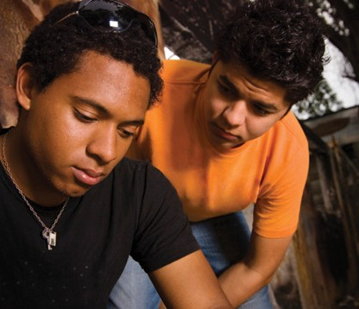on October 1-2, 2012 of a national panel of program administrators, faculty and practitioners. During the meeting, participants provided expert input on knowledge, values and practice behaviors to address behavioral health disparities for each of the ten social work competencies. This meeting was facilitated by members of the project’s executive committee. The materials were correlated and a document drafted by the Principle Investigator. These practice behaviors provide a framework to guide curriculum development for training social work practitioners to integrate behavioral health disparities content into social work curricula to implement comprehensive and innovative interventions that promote behavioral health equity.
“
. . . Latinos are severly under-
represented

| Identify as a professional social worker and conduct oneself with cultural humility.

Social workers serve as representatives of the profession, its mission and its core values.
Social Workers with advanced competence in behavioral health disparities are keenly aware of the multidimensional, interactive determinants of behavioral health disparities and the deleterious
impacts they have upon individuals, families, communities and populations.

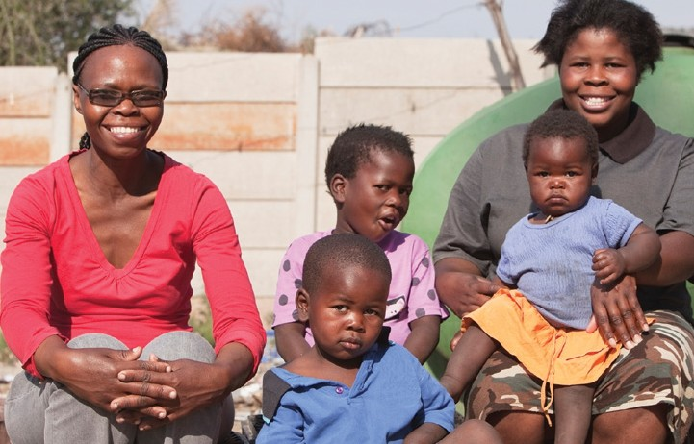As social workers they apply a strengths-based approach to practice; demonstrate self-reflection, self-awareness, and cultural humility in practice; and integrate an understanding of the social determinants of behavioral health and health equity into all aspects
of their practice. They continually seek supervision that prepares them to confront biases and value conflicts in their practice. They are committed to life-learning and continually updating knowledge and skills necessary to understand and intervene to reduce behavioral health disparities and enhance health equity, including through increasing access, continuity, quality, appropriateness, and effectiveness of behavioral health care.

Knowledge

- Understand multidimensional determinants of behavioral health disparities
and their interacting nature.
- Understand multidimensional strategies in order to promote behavioral
health equities at all levels.

Practice Behaviors

Social workers will:

- Demonstrate a commitment to the ongoing assessment of behavioral health needs and strengths of individuals, families, groups, communities, and organizations.
- Participate in the ongoing development and use of evidence-informed and
community-based strategies that promote behavioral health equity.
- Promote behavioral health equity across social, psychological, environmental
and economic contexts.
- Actively engage in inter-professional collaborations at all levels of practice with knowledge of multidimensional aspects of behavioral health disparities awareness.
- Follow the research literature on best practices for addressing behavioral
health disparities.

| Apply social work ethical principles to guide professional practice approaches to address behavioral health disparities and health equities.

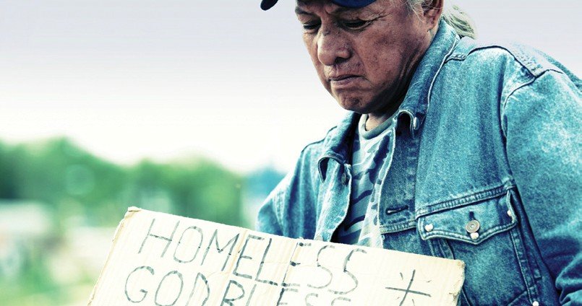Social workers have an obligation to conduct themselves ethically and to engage in ethical decision making. Social workers are knowledgeable about the value base of the profession, its ethical standards and relevant law.

Knowledge
- Have a strong working knowledge of how the NASW Code of Ethics supports health
equity.
- Understand the basic principles and concepts of equity and health.
- Understand the Universal Declaration of Human Rights, and, as applicable, the IFSW/
IASSWE Ethics in Social Work.
- Have a basic knowledge of ethical principles from related behavioral health
disciplines.

Practice Behaviors
Social workers will:
- Manage personal values in a way that allows professional values to guide practice.
- Apply social work values and ethical principles in practice approaches to address behavioral health disparities that reflect health and wellness as a social justice and human rights issue.
- Practice ethically, using a cultural humility and social justice practice paradigm.
- Integrate the ethical codes for practice from multiple professions when using a trans-
disciplinary approach to reduce behavioral health disparities.
- Apply strategies of ethical reasoning across social and ecological systems to arrive at principled decisions towards preventing, reducing and eventually eliminating behavioral health disparities.

| Apply critical thinking to inform and communicate professional judgments.

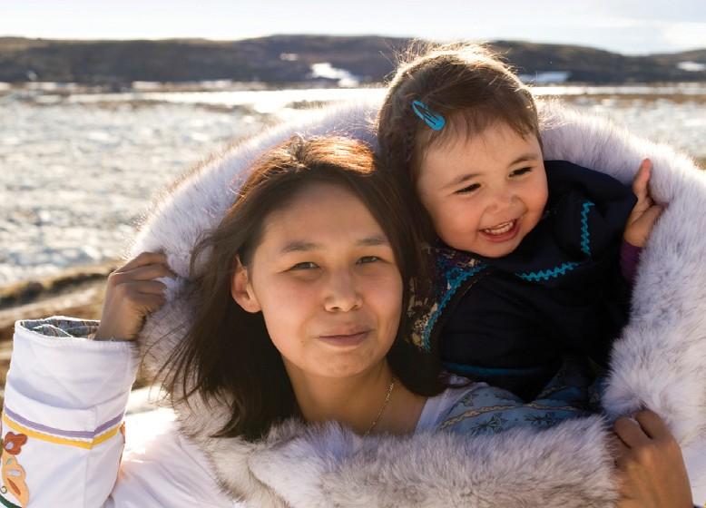Social workers are knowledgeable about the principles of logic, scientific inquiry, and reasoned discernment of behavioral health disparities affecting disadvantaged groups, including racial and ethnic minorities globally.
They use critical thinking augmented by creativity and curiosity. Critical thinking also requires the synthesis and communication of relevant information.

Knowledge
- Skills to conduct analysis and assessment of behavioral health disparities in the context of diverse identities drawing on race, ethnicity, culture, social economic status, gender, sexual orientation, immigration status and other socially constructed factors.
- The structural and community factors of behavioral health disparities in the
context of public health and prevention.
- Within-group differences and across-groups similarities.
- A critical consciousness drawing from the combination of self-knowledge and
considerations of power and privilege.

Practice Behaviors
Social workers will:

- Use cultural and community-focused and informed adaptations of evidence-based practices in order to prevent, reduce and eventually eliminate behavioral health disparities.
- Address health status and behavioral health disparities in the context of community
and societal strengths and challenges.

| Engage diversity and difference in practice.

Social workers understand how diversity characterizes and shapes the human experience and is critical to the formation of identity.
The dimensions of diversity are understood as the intersectionality
of multiple factors including age, SES color, culture, disability, ethnicity, gender, gender identity and expression,
immigration status, political ideology, race, religion, sex and sexual orientation.
Social workers appreciate that, as a consequence of
difference, a person’s life experiences
may include oppression, poverty, marginalization and alienation as well as privilege and power.

Knowledge
- Understand social dynamics such as discrimination, biases, institutional racism, and
unequal access to resources, poverty, and differential environmental challenges.
- Understand the vulnerability of marginalized populations to social determinants
of health and behavioral health care delivery barriers.

Practice Behaviors
Social workers will:

- Recognize the extent to which the health care delivery system, societal structures, agents, values, and cultural systems may oppress, marginalize, alienate, exclude, or create and enhance privilege and power.
- Demonstrate self-awareness to work towards eliminating the influence of personal biases and values in working with diverse groups in social and ecological systems.
- Apply themselves as learners and engage clients and client’s systems as informants
and experts.
- Actively promote and engage in inter-professional collaborations and co-learning
environments.

| Advance human rights and social and economic justice.

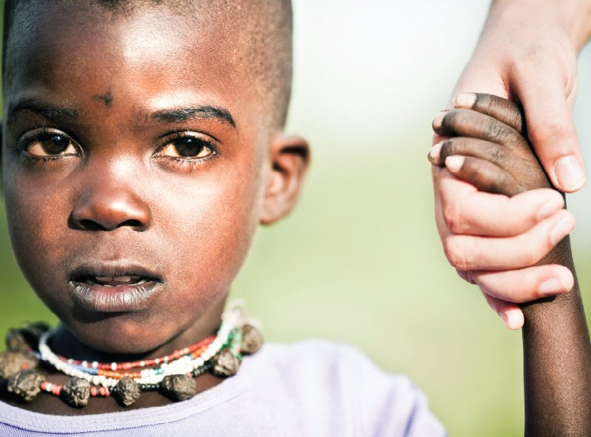Each person, regardless of position in society, has
basic human rights, such as freedom, safety, privacy, an adequate standard of living, health care and education. Social workers recognize the global interconnections of oppression and are knowledgeable about theories of justice and strategies to promote human and civil rights.
Social work incorporates social justice practices in organizations, institutions and society to ensure that these basic health and human rights are distributed equitably and without prejudice.

Practice Behaviors
Social workers will:

- Engage in advocacy to reduce behavioral health disparities.
- Engage in activities to eliminate access and service barriers to quality
behavioral health services.
- Work collaboratively with all stakeholders to decrease behavioral health
barriers to access and services.

Knowledge
- Understand various advocacy strategies for promoting health equity and
health justice.
- Understand culturally grounded practice guidelines.
- Understand that quality health and behavioral health care is a basic human
right.
- Understand that barriers related to access and services are rooted in power
imbalances, social location and social policies

| Engage in research-informed practice and practice-informed research.

Social workers use evidenced-based culturally grounded practice experience to inform research, employ evidence- based interventions, evaluate their own practice and use research findings
to improve practice across care settings and populations. Social workers comprehend quantitative
and qualitative research methods and understand scientific and ethical
approaches to building knowledge.

Knowledge
- Well-grounded in the communities that are the focus of their practice.
- Understand how to develop and assess culturally-grounded approaches to
behavioral health disparities.
- Have recent knowledge of various models of service utilization.
- Understand the ethical guidelines for undertaking research in diverse communities
around concerns with behavioral health disparities.
- Have knowledge of the various non-communicable diseases (e.g., obesity, diabetes,
osteoporosis, hypertension, mental health, etc.).

Practice Behaviors
Social workers will:
- Participate in research that illuminates causes of behavioral health disparities at community, national, and international levels and strategies for the implementation of responses to prevent, reduce and eventually eliminate behavioral health disparities.
- Develop communication skills appropriate for the translation of research findings to
diverse community members.
- Draw with discernment on culturally sensitive research on health and behavioral
health disparities.
- Engage effectively with stakeholders in developing evidence-supported and practice-
relevant social work interventions to behavioral health disparities.

| Apply knowledge of human behavior and the social environment.

Social workers are knowledgeable about human behavior across the life course; the range of social systems in which people live; and the ways social systems promote or deter people
in maintaining or achieving health and well-being. Social workers apply theories and knowledge from the liberal arts to understand biological, social, cultural, psychological, and spiritual development.

Knowledge
- Understand advanced theoretical frameworks and models of social determinants of health to guide the processes of assessment, intervention, and evaluation.
- Understand social and psychological change theories and the intersections between behavioral health and other service systems (e.g., criminal justice, child welfare, schools, etc.).
- Understand proximal and distal contextual risk factors for behavioral
health disparities.

Practice Behaviors
Social workers will:
- Utilize epidemiological data that are rooted in social and environmental contexts to understand how they differentially affect marginalized populations’ environments to impact behavioral health and genetic susceptibilities.
- Identify strengths and culturally grounded protective factors as assets in
addressing behavioral health dipartites.
- Promote and implement a wellness practice paradigm.
- Engage in inter-professional practice across disciplines to reduce behavioral
health disparities.
- Critique and apply knowledge about person and environment in the
context of behavioral health disparities.

    - | Engage in policy practice to address the social determinants of health, advance social, economic, psychological, and environmental well-being and deliver effective culturally-grounded social work services to prevent, reduce and eventually eliminate behavioral health disparities.

Social workers apply knowledge of the history and current structures of societies to develop policies that support health equity, the development of healthier communities and the improvement of behavioral health care service delivery.

Knowledge

- Understand the implications of fiscal, welfare, and health policies for practice
approaches that address behavioral health inequalities.
- Understand the policy process and how to intervene to change and develop
new policies related to behavioral health inequalities.
- Understand the process of policy evaluation and advocacy and their use in
improving and reforming policies.

Practice Behaviors

Social workers will:
- Apply analytical knowledge to assess the impact of policies on behavioral
health practices and their outcomes.
- Engage in the development of evidence-based policies to address behavioral
health disparities.
- Engage in community-based participatory research and policy assessment
in partnership with affected communities.
- Engage in advocacy for evidence-based and community-based practice in
partnership with communities, other professions and other stakeholders.

    - | Respond to contexts that shape practice.

Social workers are informed, resourceful and proactive
in responding to evolving organizational, community, societal, environmental and cultural contexts at all levels of practice. Social workers recognize that the context of practice is dynamic, and use knowledge and skill to respond proactively.

Knowledge

- Understand how organizational and community structures impede and
impact health access and quality.

- Anticipate and know how to respond to changing cultural, political,
economic and societal contexts.

Practice Behaviors

Social workers will:

- Appraise and address changing and/or emerging social and ecological
trends and processes to provide culturally informed services.

- Engage with strategies for working with clients’ settings and systems to effect environmental and policy change towards the prevention, reduction and eventual elimination of behavioral health disparities.

- Utilize leadership skills to promote sustainable changes in service delivery
and practice to improve the quality of interventions.

- Work with clients and systems to effect environmental and policy change.

    - | Engage, assess, intervene and evaluate with individuals, families, groups, organizations and communities.

Professional practice involves the dynamic and interactive processes of engagement, assessment, intervention and evaluation at multiple levels. Social
workers have the knowledge and skills to practice
with individuals, families, groups, organizations and communities. Practice knowledge includes identifying, analyzing and implementing evidence-
based interventions designed to achieve client goals; using research and technological advances; evaluating program outcomes and practice effectiveness; developing, analyzing, advocating and providing leadership for policies and services; and promoting social and economic justice.

Knowledge

- Understand how culture and social context influence relationships and their
development.
- Have expertise in working relationships with community members,
organizational partners, and cultural brokers.
- Have expertise in working with multiple agency partners from different
disciplines.
- How to engage with cultural narratives and local health practices.
- Understand how to develop tools such as logic models and measurement instruments in partnership and resonance with communities and their values.
- Know how to apply evaluation strategies to decisions in daily practice.
- Understand the lack of fit of many mainstream measures in a range of
cultural contexts.
- Have awareness of and conduct cultural adaptation when needed of
evidence-informed interventions.

2.1.10 a-c | Engage, assess, intervene and evaluate with individuals, families, groups, organizations and communities.

Practice Behaviors

- Engagement

Social workers work across all client systems to:

- Implement approaches for working in the context of diverse agency cultures.

- Assessment

Social workers work across all client systems to:

- Collect, organize and interpret health and behavioral health data.

- Assess clients and client’s health and behavioral health service delivery systems and community
resources for strengths, limitations, relevance and impact.

- Develop mutually agreed-upon service plans.

- Select appropriate culturally-grounded interventions.

- Engage in scenario-building and apply systems thinking.

- Develop a more advanced understanding of and empathy for community members and
local community leaders and community organizations.

- Learn to assess using a culturally grounded approach and be responsive to client needs.

- Intervention

Social workers work across all client systems to:

- Utilize culturally grounded approaches in interventions addressing behavioral health
disparities.

- Employ transdisciplinary and inter-professional intervention strategies in practice.

- Engage cultural humility in collaborative practices with stakeholders at all levels.

- Engage in practice methods to reduce inequities linked to behavioral health disparities
stemming from obstacles to access, equity and culturally grounded services.

2.1.10 d | Engage, assess, intervene and evaluate with individuals, families, groups, organizations and communities.

d. Evaluation

Social workers critically analyze, monitor and evaluate interventions, and

- Collaborate on definitions of outcomes and measures with clients, organizations and
communities.

- Apply assessment and evaluation tools to their practice and measure progress and outcomes.

- Translate and return the results of research and evaluation to clients and communities.

References

Agency for Healthcare Research and Quality. (2013). 2012 National Healthcare Disparities Report. Rockville, MD. U.S. Department of Health and Human Services.

Aday, L. A., & Andersen R. M. (1981). Equity to access to medical care: a conceptual and empirical overview. Medical Care, 19 (supplement):4-27.

Andersen R. M., & Newman J. F. (1973). Societal and individual determinants of medical care utilization in the United States. Milbank Memorial Fund Quarterly _Health and Society, 51, 95-124.
Baicker, K., Chandra, A., Skinner, J. S., & Wennberg, J. (2004). Who you are and where you live: How race and geography affect the treatment of Medicare beneficiaries. Health Affairs, 33-44.
Baicker, K., Chandra, A., & Skinner, J. S. (2005). Geographic variation in health care and the problems of measuring racial disparities. Perspectives in Biology and Medicine, 48, S42- S53.

Balca’zar, H., Alvarado, M., Hollen, M. L., Gonzalez-Cruz,Y., & Pedregn, V. (2005). Evaluation of salud para su corazn (health for your heart)_National Council of La Raza promotora outreach program. Preventing Chronic Disease, 2, 1-9.
Brave Heart, M. Y. H. (1998). The return to the sacred path: Healing the historical trauma and historical unresolved grief response among the Lakota through a psychoeducational group intervention. Smith College Studies in Social Work, 68, 287-305.
Brave Heart, M.Y.H. (2003). The historical trauma response among Natives and its relationship with substance abuse: A Lakota illustration. Journal of Psychoactive Drugs, 35, 7-13.
Braveman, P. A., Egerter, S. A., & Mockenhaupt, R. E. (2011). Broadening the focus: The need to address the social determinants of health. American Journal of Preventive Medicine, 40, S4-S18.
Brondolo, E., Gallo, L. C., & Myers, H. F. (2009). Race, racism and health: Disparities, mechanisms, and interventions.
Journal of Behavioral Medicine, 32, 1-8.DOI: 10.1007/s10865-008-9190-3.

Brondolo, E., Beatty, D. L., Cubbin, C., Weinstein, M., Saegert, S., Wellington, R., Obin, J., Cassells, A., & Shwartz, J. (2009). Sociodemographic variations in self-reported racism in a community sample of Blacks and Latino(a)s. Journal of Applied Social Psychology, 39, 407-429.

Brondolo, E., Brady, N., Pencille, M., Beatty, D., & Contrada, R. J. (2009). Coping with racism: A selective review of the literature and a theoretical and methodological critique. Journal of Behavioral Medicine, 32, 64-88. DOI: 10.1007/s10865-008-9193-0.

Casper, M. L., Denny, C. H., Coolidge, J. N., Williams, G. I. Jr., Crowell, A., Galloway, J. M., & Cobb N. (2005). Atlas of Heart Disease and Stroke among American Indians and Alaska Natives. Atlanta, GA: U.S. Department of Health and Human Services, Centers for Disease Control and Prevention and Indian Health Service.

Cauce, A. M., Cruz, R., Corona, M., & Conger, R. (2010). The face of the future: Risk and resilience in minority youth. In G. Carlo, L. J. Crockett, & M. Carranza (Eds.) Health Disparities in Youth and Families: Research and Applications (pp. 13-32). New York, NY: Springer Publishing Company.
Center for Disease Control and Prevention. (2010). Youth Risk Behavior Surveillance _ United States, 2009. Surveillance Summaries, June 2010, MMWR 2010;59(No.SS-5).

Chapa, T., & Acosta, H. (2010). Movilizandonos por nuestro futuro: Strategic development of a mental health workforce for Latinos. U.S. Department of Health and Human Services, Office of Minority Health and the National Resource Center for Hispanic Mental Health.

Children’s Defense Fund. (2011). Zero to three research to policy project: Maternal depression and early childhood full report. Saint Paul, Minnesota: Minnesota Community Foundation.

Commission on the Social Determinants of Health. (2008). Closing the gap in a generation: health equity through action on the social determinants of health. Final Report of the Commission on Social Determinants of Health. Geneva: World Health Organization.

Dahlgren, G., & Whitehead, M. (2007). Policies and strategies to promote social equity in health. Background document to WHO _ Strategy paper. Stockholm, Sweden: Institutes for Futures Studies.
Davis, K. (2011). Pathways to integrated health care: Strategies for African American communities and organizations.
United States Department of Health and Human Services, Office of Minority Health.

Escarce, J. J., & McGuire, T. G. (2004). Changes in racial differences in use of medical procedures and diagnostic tests among elderly persons: 1986-1997. American Journal of Public Health, 94, 1795-99.

Gallo, L. C., & Penedo, F. J., Espinosa de los Monteros, K., & Arguelles, W. (2009). Resiliency in the face of disadvantage: Do Hispanic cultural characteristics protect health outcomes? Journal of Personality, 77, 1707-46.

Gelberg, L., Andersen, R. M., & Leake, B. D. (2000). The behavioral model for vulnerable populations: Application to medical care use and outcomes for homeless people. Health Services Research, 34, 1273-1302.

Granado-Villar, D. C., Brown, J. M., Cotton, W. H., Mardy Gaines, B. M., Gambon, T. B., Gitterman, B. A., Gorski, P. A., Kraft, C. A., Marino, R. V., Paz-Soldan, G. J., Zind, B., Moore, K. R., Bell, J. T., Etzel, R. A., Hoffman, B. D., Ponder, S.
W., Redding, M. M., & Waldron, D. B. (2010). Policy statement _ health equity and children’s right. Pediatrics, 125,
838-49.

Greer, T. M. (2005). Interventions for bridging the gaps in minority health. In L. VandeCreek & J. B. Allen (Eds.) Innovations in Clinical Practice: Focus on Health and Wellness (pp. 145-58). Sarasota, FL: Professional Resource Press.

Hasnain-Wynia, R., Baker, D. W., Nerenz, D., Feinglass, J., Beal, A. C., Landrum, M. B., Behal, R., & Weissman, J. S. (2007). Disparities in health care are driven by where minority patients seek care. Archives of Internal Medicine, 167, 1233-39.

Healthy Communities Matter Executive Summary. (2010). The importance of place to the health of boys of color.
California: The California Endowment.

Huang, L. N., & Chau, V. (2012). Addressing behavioral health disparities. Office of Behavioral Health Equity, Administrator’s Office of Policy Planning and Innovation. Retrieved from http://crdp.pacificclinics.org/files/ resource/2012/03/Larke%20Huang%20-%20Addressing%20Behavioral%20Health%20Disparities.pdf.

Ida, D., SooHoo, J., & Chapa, T. (2012). Integrated Care for Asian American, Native Hawaiian and Pacific Islander Communities: A Blueprint for Action: Consensus Statements and Recommendations. Rockville, MD: U.S. Department of Health and Human Services, Office of Minority Health.

Indian Health Service. (2011). Fact sheets: Indian health disparities. Retrieved from http://www.ihs.gov/PublicAffairs/ IHSBrochure/Disparities.asp.

Institute of Medicine (US). Committee on Assuring the Health of the Public in the 21st Century. (2003). The Future of the Public’s Health in the 21st Century. National Academies Press.

Jha, A. K., Fisher, E. S., Li, Z., Orav, E. J. & Epstein, A. M. (2005). Racial trends in the use of major procedures among the elderly. The New England Journal of Medicine, 353, 683- 92.
Kaholokula, J. K., Nacapoy, A. H., & Dang, K. (2009). Social justice as a public health imperative for Ka-nakaMaoli.
AlterNative, 5, 117-37.

Koenig, H. G. (2009). Research on religion, spirituality, and mental health: A review. The Canadian Journal of Psychiatry, 54, 283-91.

Klonoff, E. A. (2009). Disparities in the provision of medical care: An outcome in search of an explanation. Journal of Behavioral Medicine, 32, 48-63.

Kumanyika, S. K. & Morssink, C. B. (2006). Bridging domains in efforts to reduce disparities in health and health care.
Health Education & Behavior, 33, 440-58.

LaFromboise, T. D., Hoyt, D. R., Oliver, L., & Whitbeck, L. B. (2006). Family, community, and school influences on resilience among American Indian adolescents in the upper Midwest. Journal of Community Psychology, 34, 193-209.

Lo, C. C., & Cheng, T. C. (2011). Racial/ethnic differences in access to substance abuse treatment. Journal of Health Care for the Poor and Underserved, 22, 621-37.

Matarazzo, J.D. (1980). Behavioral health and behavioral medicine: Frontiers for a new health psychology. American Psychologist, 35, 807-17

Mather, M., Pollard, K., & Jacobsen, L. A. (2011). First results from the 2010 Census. Washington, DC: Population Reference Bureau. Retrieved from http://www.prb.org/pdf11/reports-on-america-2010-census.pdf.

McGuire, T. G., & Miranda, J. (2008). New evidence regarding racial and ethnic disparities in mental health: Policy implications. Health Affairs, 27, 393-403.

Nagata, D. (1998). Transgenerational impact of the Japanese-American internment. In Y. Danieli (Ed.) International Handbook of Multigenerational Legacies of Trauma, (pp. 125-40). New York: Plenum Publishing.

Ortiz, L., Arizmendi, L., & Cornelius, L. J. (2004). Access to health care among rural Mexican Americans. Journal of Rural Health, 20, 246-52.

Peek, C. J. & the National Integration Academy Council. (2013). Lexicon for Behavioral Health and Primary Care Integration: Concepts and Definitions Developed by Expert Consensus. AHRQ Publication No.13-IP001-EF. Rockville, MD: Agency for Healthcare Research and Quality. 2013. Retrieved from: http://integrationacademy. ahrq.gov/sites/default/files/Lexicon.pdf.

Plescia, M., Herrick, H., & Chazis, L. (2008). Improving Health Behaviors in an African American community: The Charlotte racial and ethnic approaches to community health project. American Journal of Public Health, 98, 1678-84.

Reinschmidt, K. M. Hunter, J. B. Fernandez, M. L., Lacy-Martinez, C. R., Guernsey de Zapien, J., & Meister, J. (2006). Understanding the success of promotoras in increasing chronic disease screening. Journal of Health Care for the Poor and Underserved, 17, 256-64.

Rhodes, S. D., Foley, K. L., Zometa, C. S., & Bloom, F. R. (2007). Lay health advisor interventions among Hispanics/ Latinos: A qualitative systematic review. American Journal of Preventive Medicine, 33, 418-27.

Schneider, E. L., Zaskavzky, D. J., & Epstein, J. M. (2002). Racial disparities in the quality of care for enrollees in Medicare managed care. Journal of American Medical Association, 287, 1288-94.

Smedley, B. D. (2006). Expanding the frame of understanding health disparities: From a focus on health systems to social and economic systems. Health Education & Behavior, 33, 538-41.

Smedley, B., Stith, A., & Nelson, A. (Eds), (2002). Unequal treatment: Confronting racial and ethnic disparities in health care. Washington, DC: National Academies Press.

Spencer, M. S., Rosland, A., Kieffer, E. C., Sinco, B. R., Valerio, M., Palmisano, G., Anderson, M., Guzman, J. R., & Heisler,
M. (2011). Effectiveness of a community health worker intervention among African American and Latino adults with Type 2 diabetes: A randomized controlled trial. Research and Practice, 101, 2253-60.

Stein, B. D., Jaycox, L. H., Kataoka, S. H., Wong, M., Tu, W., Elliott, M. N., & Fink, A. (2003). A mental health intervention for schoolchildren exposed to violence: A randomized controlled trial. Journal of the American Medical Association, 290, 603-70.

Steinberg, A. (1989). Holocaust survivors and their children: A review of the clinical literature. In P. Marcus, & A. Rosenberg (Eds.), Healing Their Wounds: Psychotherapy with Holocaust Survivors and Their Families (pp. 23-48). New York: Praeger.

Sue, S., & Chu, J. Y. (2003). The mental health of ethnic minority groups: Challenges posed by the supplement to the surgeon general’s report on mental health. Culture, Medicine and Psychiatry, 27, 447-65.

Trivedi, A. N., Zaslavzky, A. M., Schneider, E. C., & Ayanian, J. Z. (2006). Relationship between quality of care and racial disparities in Medicare health plans. Journal of the American Medical Association, 296, 1998-2004.

U.S. Census Bureau News. (2008). An older and more diverse nation by midcentury. Retrieved from: www.census. gov/Press-Release/www/releases/archives/populations/012496.html.

U.S. Census Bureau News. (2012). 2012 National Population Projections. Retrieved from: http://www.census.gov/ population/projections/data/national/2012.html.

U.S. Congress. (2010). Patient Protection and Affordable Care Act 2010. Retrieved from: http://www.gpo.gov/fdsys/ pkg/BILLS-111hr3590enr/pdf/BILLS-111hr3590enr.pdf.

U.S. Department of Labor, Bureau of Labor Statistics. (2011). Household Data Annual Averages: Employed persons by details occupation, sex, race, and Hispanic or Latino ethnicity. Retrieved from: http://www.bls.gov/cps/ cpsaat11pdf.

U.S. Department of Health and Human Services. (2001). Mental Health: Culture, Race, and Ethnicity _ Supplement to Mental Health: A Report of the Surgeon General. Rockville, MD: Substance Abuse and Mental Health Services Administration, Center for Mental Health Services.

U.S. Department of Health and Human Services. (2011). HHS Action Plan to Reduce Health Disparities, a Nation free of disparities in health and health care. Retrieved from: minorityhealth.hhs.gov/npa/files/Plans/HHS/HHS_Plan_ complete.pdf.

U.S. Department of Health and Human Services. (2013). The National Standards for Culturally and Linguistically Appropriate Services in Health and Health Care (the National CLAS Standards) Retrieved from: https://www. thinkculturalhealth.hhs.gov/Content/clas.asp

Whitbeck, L.B., Adams, G.W., Hoyt, D.R., & Chen, X. (2004). Conceptualizing and measuring historical trauma among American Indian people. American Journal of Community Psychology, 33, 119-130.

Whitbeck, L. B., Hoyt, D., Stubben, J., & LaFromboise, T. (2001). Traditional culture and academic success among American Indian children in the upper Midwest. Journal of American Indian Education, 40, 48-60.

Whitbeck, L. B., McMorris, B. J., Hoyt, D. R., Stubben, J. D., & LaFramboise, T. (2002). Perceived discrimination, traditional practices, and depressive symptoms among American Indians in the upper Midwest. Journal of Health and Social Behavior, 43, 400-18.

Whitehead, M. (1992). The concepts and principles of equity and health. International Journal of Health Services: Planning, Administration, and Evaluation, 22, 429-45.

WHO Commission on Social Determinants of Health. (2008). Closing the Gap in a Generation: Health Equity Through Action on the Social Determinants of Health: Final Report of the Commission on Social Determinants of Health. World Health Organization.

Williams, D. R., Costa, M. V., Odunlami, A. O., & Mohammed, S. A. (2008). Moving upstream: How interventions that address the social determinants of health can improve health and reduce disparities. Journal of Public Health Management Practice, 14 (Suppl.), 8-17.

Williams, D. R., & Mohammed, S. A. (2009), Discrimination and racial disparities in health: Evidence and needed research. Journal of Behavioral Medicine, 20, 20-47.

Williams, J. H., Auslander, W. F., de Groot, M., Robinson, A., Houston, C., & Haire-Joshu, D. (2006). Cultural relevancy of a diabetes prevention nutrition program for African American women. Health Promotion Practice, 7, 56-67.

Yehuda, R. (1999). Biological factors associated with susceptibility to post-traumatic stress disorder. Canadian Journal of Psychiatry, 44, 3439.

Behavioral Health Disparities Curriculum Project Advanced Practice Behaviors Panel Participants

Yolanda Anyon, PhD
University of Denver
Graduate School of Social Work Denver, CO

Robert Atwell, PsyD Private Practice Denver, CO

Terri Browne, PhD University of South Carolina College of Social Work Columbia, SC

Leopoldo J. Cabassa, PhD Columbia University School of Social Work New York, NY

Teresa Chapa, PhD, MPA
U.S. Department of Health and Human Services (HHS)
Office of Minority Health
Latino Behavioral Health Institute Rockville, MD

Jim Garcia, MPA Clínica Tepeyac Denver, CO

Sarah Gehlert, PhD
Washington University in St. Louis George Warren School of Social Work St. Louis, MO

Antonio Gonzalez-Prendes, PhD
Wayne State University School of Social Work, Detroit, MI
Hyeouk Chris Ham, PhD Boston University School of Social Work Boston, MA

Emily Ihara, PhD
Department of Social Work
College of Health & Human Services George Mason University
Fairfax, VA

Vivian H. Jackson, PhD
National Center for Cultural Competence and National Technical Assistance
Center for Children’s Mental Health Georgetown University
Center for Child & Human Development Washington, DC

Sharon Johnson, PhD Department of Social Work University of Missouri St Louis St. Louis, MO

Laura Lein, PhD University of Michigan School of Social Work Ann Arbor, MI

Flavio Marsiglia, PhD
Southwest Interdisciplinary Research Center Arizona State University
School of Social Work Phoenix, AZ

Joseph R. Merighi, PhD University of Minnesota School of Social Work Saint Paul, MN

Von Eugene Nebbitt, PhD
Jane Addams School of Social Work University of Illinois Chicago Chicago, Illinois

Larry Ortiz, PhD, MSW
Department of Social Work & Social Ecology Loma Linda University
Loma Linda, CA

Juan Pena, PhD
Silberman School of Social Work Hunter College
New York, NY

Lissete M. Piedra, PhD
University of Illinois at Urbana/Champaign School of Social Work
Urbana, IL

Guitele Rahill, PhD University of South Florida School of Social Work Tampa, FL

Jo Ann R. Coe Regan, PhD Council on Social Work Education Alexandria, VA

Katherine Sanchez, PhD University of Texas at Arlington School of Social Work Arlington, TX

Lorraine Moya Salas, PhD Unlimited Potential Phoenix, AZ

Yvette Sealy, PhD Fordham University School of Social Service New York, NY
Michael Spencer, PhD University of Michigan School of Social Work Ann Arbor, MI

Patrick Sullivan, PhD Indiana University School of Social Work Indianapolis, IN

Edwina S. Uehara, PhD, MSW University of Washington School of Social Work Seattle, WA

James Herbert Williams, PhD, MSW, MPA
University of Denver
Graduate School of Social Work Denver, CO

Staff

Vitali Chamov, MA
National Association of Deans and Directors of Schools of Social Work
Alexandria, VA

Eric A. Des Marais, MSW
University of Denver
Graduate School of Social Work Denver, CO

NADD
The National Association of Deans and Directors of Schools of Social Work

The National Association of Deans and Directors of Schools of Social Work (NADD) is a volunteer membership organization working to promote excellence in social work education. NADD achieves this by enhancing the leadership of social work education programs. Our membership is comprised of deans and directors of graduate social work programs that are accredited or advanced to candidacy. NADD supports deans and directors in their professional development and effectiveness as academic administrators.

NADD offers leadership support involving:
- Educational excellence
- Research infrastructure development
- Fundraising and development agendas
- Outreach and community capacity building
- Evidence based and culturally competent practice in social work
- Effective impacts on educational and practice policies
- The promotion of strong local and global partnerships

NADD also sponsors several Task Forces.


1701 Duke Street, Suite 200
Alexandria, VA 22314 naddssw@cswe.org Phone: 703-683-8080
Fax: 703-683-8099

www.naddssw.org

1701 Duke Street, Suite 200
Alexandria, VA 22314 naddssw@cswe.org Phone: 703-683-8080
Fax: 703-683-8099

www.naddssw.org

